CREATE TABLE person (

person_id VARCHAR (50)); 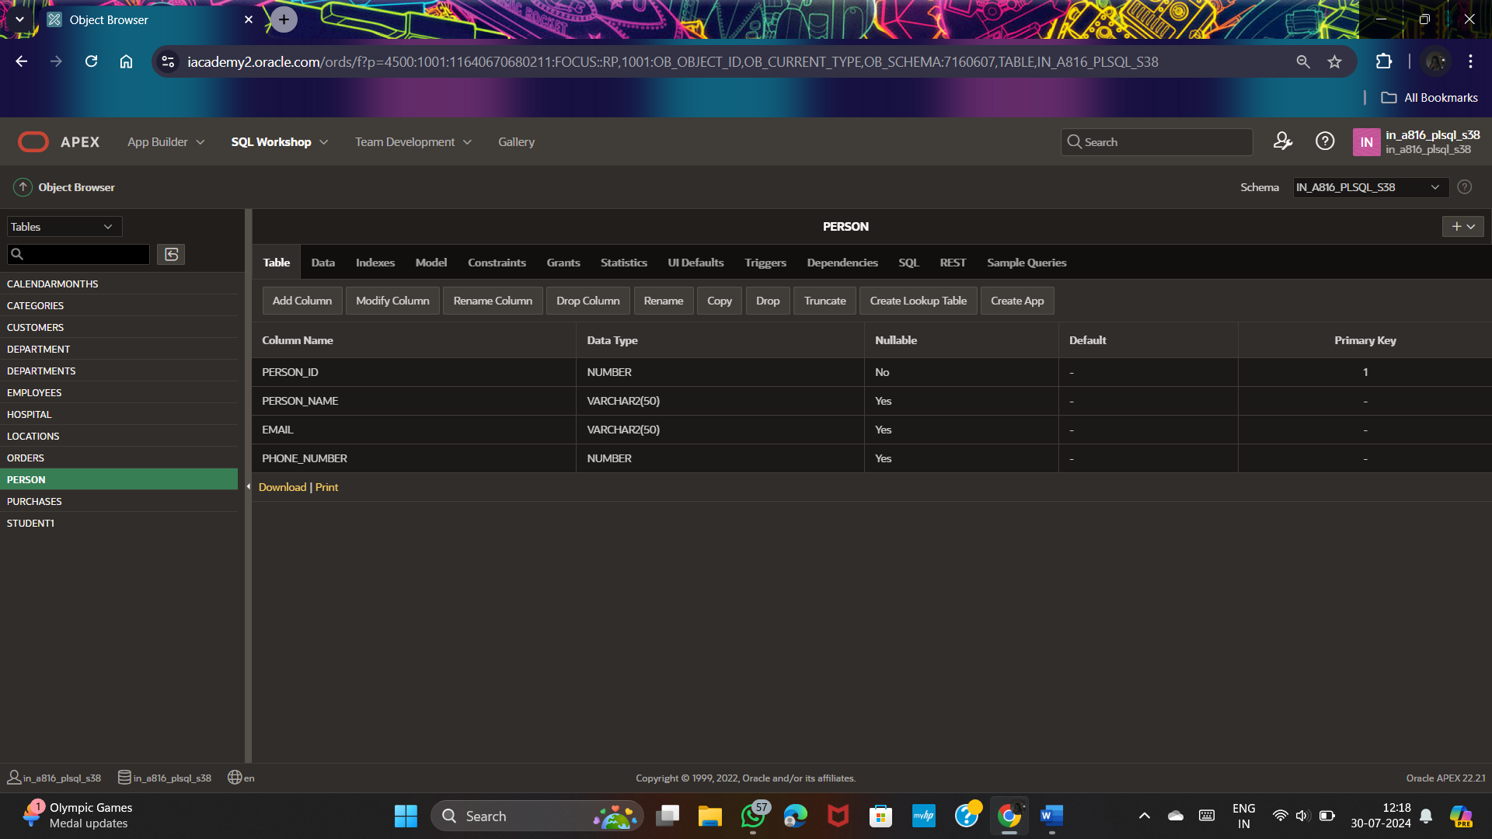

CREATE TABLE orders(orders_id NUMERIC PRIMARY KEY , person_id NUMERIC NOT NULL,order_date NUMERIC,product VARCHAR(50));

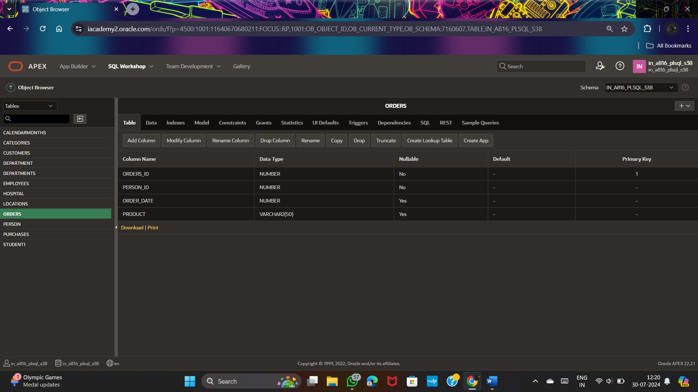

ALTER TABLE orders

ADD FOREIGN KEY(person_id) REFERENCES person(person_id);

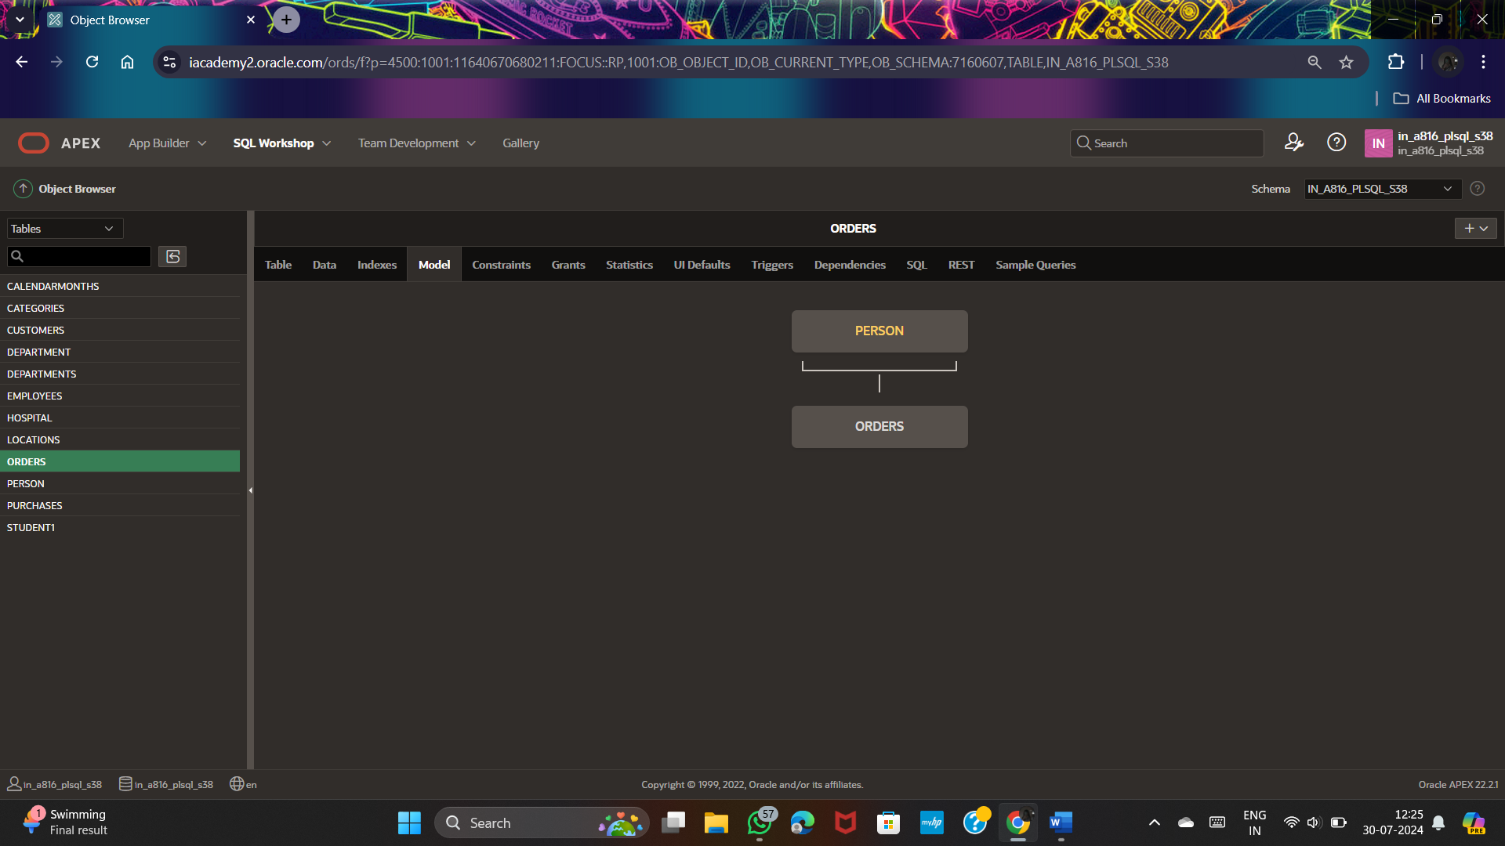

SELECT *

FROM orders

join person

on orders.person_id = person.person_id;

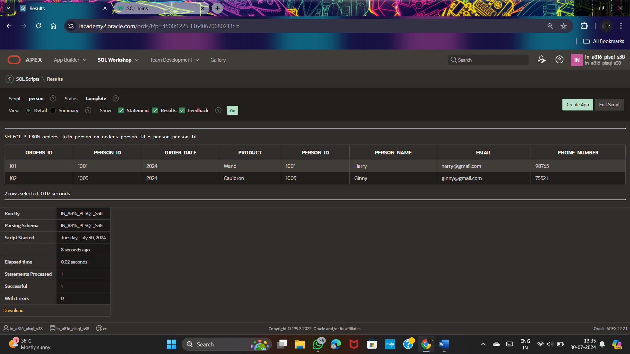

CREATE TABLE employee(

firstname VARCHAR(50),lastname VARCHAR(50),department_id NUMERIC,salary NUMERIC,email VARCHAR(30)

);

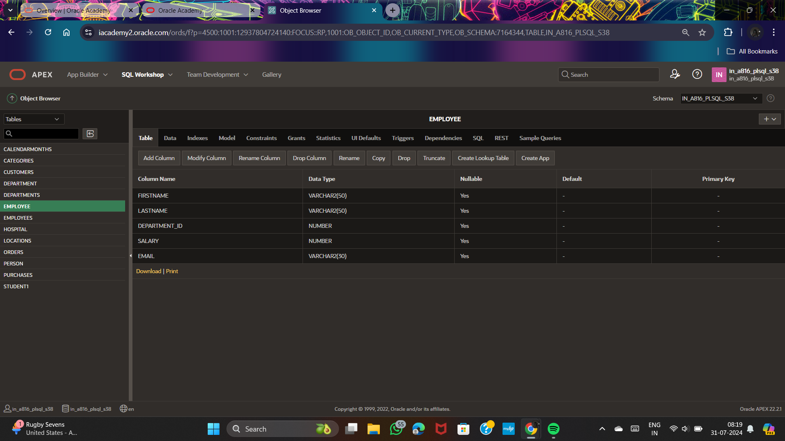

SELECT lastname,

CASE department_id

WHEN 90 THEN 'management'

WHEN 80 THEN 'sales'

WHEN 60 THEN 'it'

ELSE 'Other dept.'

END AS department

FROM employee;

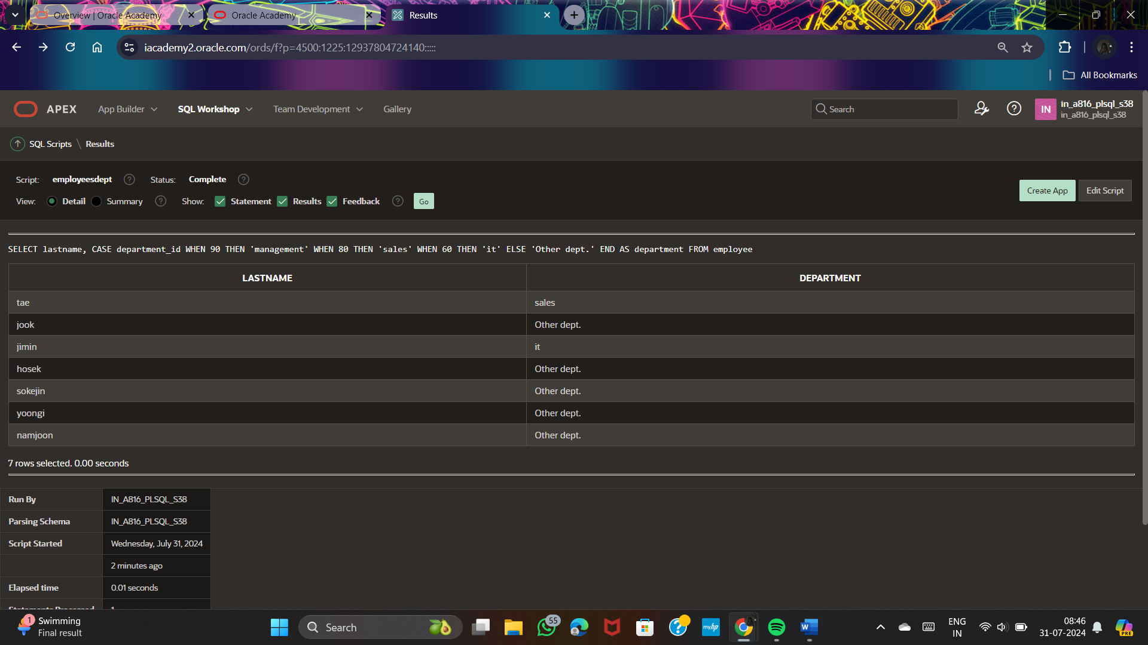

SELECT person_id, person_name

FROM person NATURAL JOIN

orders;

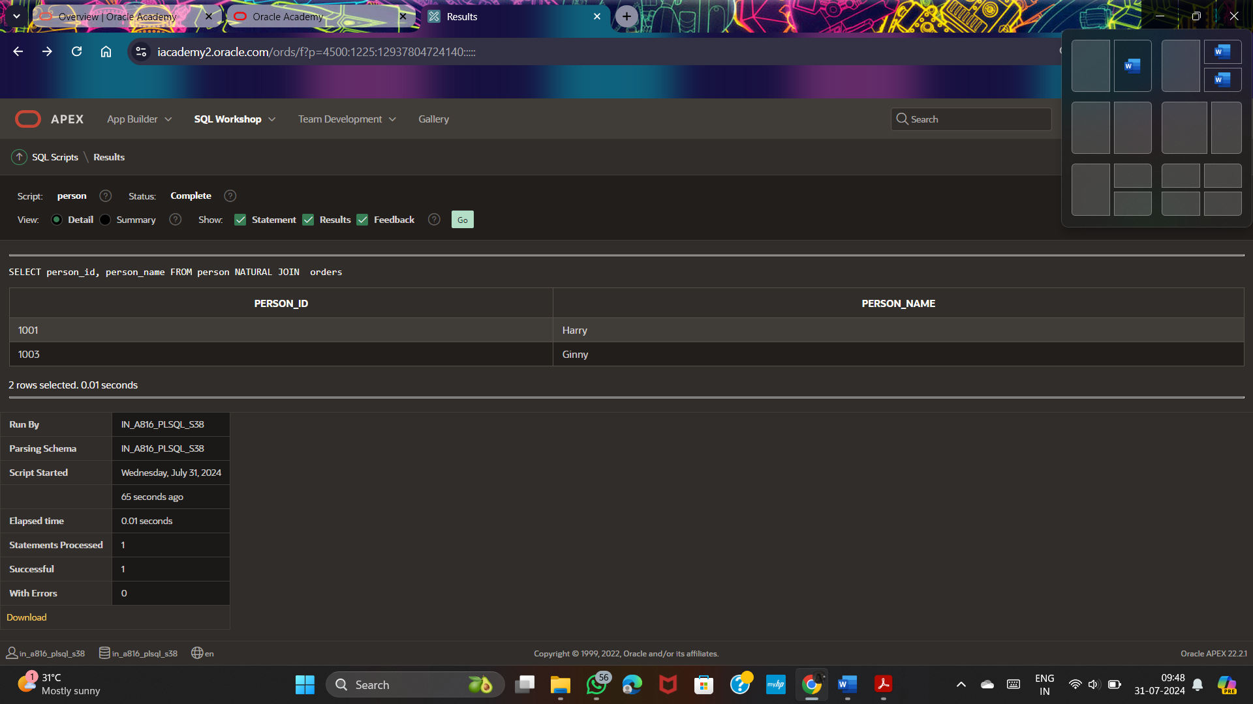

SELECT person_id, person_name

FROM person JOIN orders using (person_id)

WHERE person_id = 1001;

